**DHT11 Humidity &**

**Temperature Sensor**

DHT11 Temperature & Humidity Sensor features a

temperature & humidity sensor complex with a

calibrated digital signal output

.

DHT 11 Humidity & Temperature

Sensor

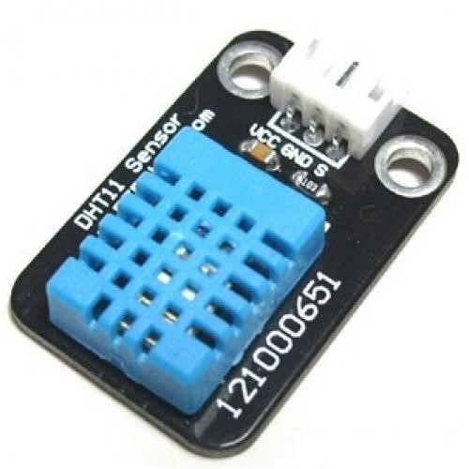

# 1. Introduction

This DHT11 Temperature & Humidity Sensor features a temperature & humidity sensor complex with a calibrated digital signal output. By using the exclusive digital-signal-acquisition technique and temperature & humidity sensing technology, it ensures high reliability and excellent long-term stability. This sensor includes a resistive-type humidity measurement component and an NTC temperature measurement component, and connects to a high-

performance 8-bit microcontroller, offering excellent quality, fast response, anti-interference ability and cost-effectiveness.

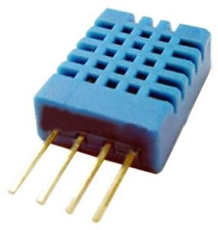

Each DHT11 element is strictly calibrated in the laboratory that is extremely accurate on humidity calibration. The calibration coefficients are stored as programmes in the OTP memory, which are used by the sensor’s internal signal detecting process. The single-wire serial interface makes system integration quick and easy. Its small size, low power consumption and up-to-20 meter signal transmission making it the best choice for various applications, including those most demanding ones. The component is 4-pin single row pin package. It is convenient to connect and special packages can be provided according to users’ request.

**2. Technical Specifications:**

**Overview:**

|  |  |  |  |  |  |
| --- | --- | --- | --- | --- | --- |
| Item | Measurement Range | Humidity Accuracy | Temperature Accuracy | Resolution | Package |
| DHT11 | 20-90%RH  0-50 ℃ | ±5％RH | ±2℃ | 1 | 4 Pin Single  Row |

**Detailed Specifications:**

|  |  |  |  |  |
| --- | --- | --- | --- | --- |
| **Parameters** | **Conditions** | **Minimum** | **Typical** | **Maximum** |
| **Humidity** |  | |  |  |
| **Resolution** |  | 1%RH | 1%RH | 1%RH |
|  | 8 Bit |  |
| **Repeatability** |  |  | ±1%RH |  |
| **Accuracy** | 25℃ |  | ±4%RH |  |
| 0-50℃ |  |  | ±5%RH |
| **Interchangeability** | Fully Interchangeable | |  |  |
| **Measurement Range** | 0℃ | 30%RH |  | 90%RH |
| 25℃ | 20%RH |  | 90%RH |
| 50℃ | 20%RH |  | 80%RH |
| **Response Time (Seconds)** | 1/e(63%)25℃，  1m/s Air | 6 S | 10 S | 15 S |
| **Hysteresis** |  |  | ±1%RH |  |
| **Long-Term**  **Stability** | Typical |  | ±1%RH/year |  |
| **Temperature** |  |  |  |  |
| **Resolution** |  | 1℃ | 1℃ | 1℃ |
|  | 8 Bit | 8 Bit | 8 Bit |
| **Repeatability** |  |  | ±1℃ |  |
| **Accuracy** |  | ±1℃ |  | ±2℃ |
| **Measurement Range** |  | 0℃ |  | 50℃ |
| **Response Time (Seconds)** | 1/e(63%) | 6 S |  | 30 S |

# 3. Typical Application (Figure 1)

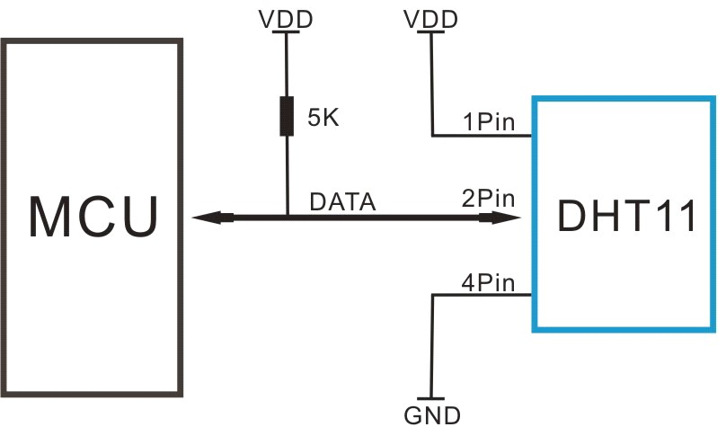

**Figure 1 Typical Application**

Note: 3Pin – Null; MCU = Micro-computer Unite or single chip Computer

When the connecting cable is shorter than 20 metres, a 5K pull-up resistor is recommended; when the connecting cable is longer than 20 metres, choose a appropriate pull-up resistor as needed.

# 4. Power and Pin

DHT11’s power supply is 3-5.5V DC. When power is supplied to the sensor, do not send any instruction to the sensor in within one second in order to pass the unstable status. One capacitor valued 100nF can be added between VDD and GND for power filtering.

# 5. Communication Process: Serial Interface (Single-Wire Two-Way)

Single-bus data format is used for communication and synchronization between MCU and DHT11 sensor. One communication process is about 4ms.

Data consists of decimal and integral parts. A complete data transmission is **40bit**, and the sensor sends **higher data bit** first.

**Data format:** 8bit integral RH data + 8bit decimal RH data + 8bit integral T data + 8bit decimal T data + 8bit check sum. If the data transmission is right, the check-sum should be the last 8bit of "8bit integral RH data + 8bit decimal RH data + 8bit integral T data + 8bit decimal T data".

## 6. Attentions of application

### (1) Operating conditions

Applying the DHT11 sensor beyond its working range stated in this datasheet can result in 3%RH signal shift/discrepancy. The DHT11 sensor can recover to the calibrated status gradually when it gets back to the normal operating condition and works within its range. Please refer to (3) of this section to accelerate its recovery. Please be aware that operating the DHT11 sensor in the non-normal working conditions will accelerate sensor’s aging process.

### (2) Attention to chemical materials

Vapor from chemical materials may interfere with DHT’s sensitive-elements and debase its sensitivity. A high degree of chemical contamination can permanently damage the sensor.

### (3) Restoration process when (1) & (2) happen

Step one: Keep the DHT sensor at the condition of Temperature 50~60Celsius, humidity <10%RH for 2 hours;

Step two:K keep the DHT sensor at the condition of Temperature 20~30Celsius, humidity >70%RH for 5 hours.

### (4) Temperature Affect

Relative humidity largely depends on temperature. Although temperature compensation technology is used to ensure accurate measurement of RH, it is still strongly advised to keep the humidity and temperature sensors working under the same temperature. DHT11 should be mounted at the place as far as possible from parts that may generate heat.

**(5) Light Affect**

Long time exposure to strong sunlight and ultraviolet may debase DHT’s performance.

### (6) Connection wires

The quality of connection wires will affect the quality and distance of communication and high quality shielding-wire is recommended.

### (7) Other attentions

* Welding temperature should be bellow 260Celsius and contact should take less than 10 seconds.
* Avoid using the sensor under dew condition.
* Do not use this product in safety or emergency stop devices or any other occasion that failure of DHT11 may cause personal injury.
* Storage: Keep the sensor at temperature 10-40℃, humidity <60%RH.